Chris Vann, Serena Warner, Grace Sweeney
Dr. Drew Guarnera
CS-214: Database Systems
April 29, 2026
Final Report: Music Purchasing Habits
Our dataset for this analysis is modeled after data from a digital music store, a fictional store named Chinook. We sourced the data from GitHub, where it was already separated into eleven .csv files to represent different entities in a database. The files include data on the store’s customers and employees, as well as information related to individual transactions, such as tracks purchased and transaction totals.
In order to create a more concise database, we cleaned the data in several ways. We first determined attributes of the data that were not relevant to our analysis. Specifically, we did not include any of the data on employees, playlists, or media types in our database, as well as exact customer addresses and track composers. Another crucial step of the data cleaning process was parsing the data from the artist file. The artist file lists artists with a surrogate key, artist_id. However, some rows of the data list multiple artists in the same cell due to collaborations. The first step we took in approaching this issue was adding a new delimiter to split the artist data on and then removing the feature artists from the artist data. To prevent redundancy in the data, each artist was added to the database just once. In cleaning the artist table, it became difficult to map artists to their album, as artist_id had broken down. Due to this difficulty, we created a Python dictionary, mapping the original artist's IDs to their corresponding artists in the cleaned CSV data, and then using the custom delimiter to split these values. The keys of this dictionary were the original IDs while the values were lists of associated artist names. We then created a junction table between artist and album that mapped a new, auto-incrementing artist ID to the original artist ID that matched the album data. This allowed multiple artists to be responsible for the same album.
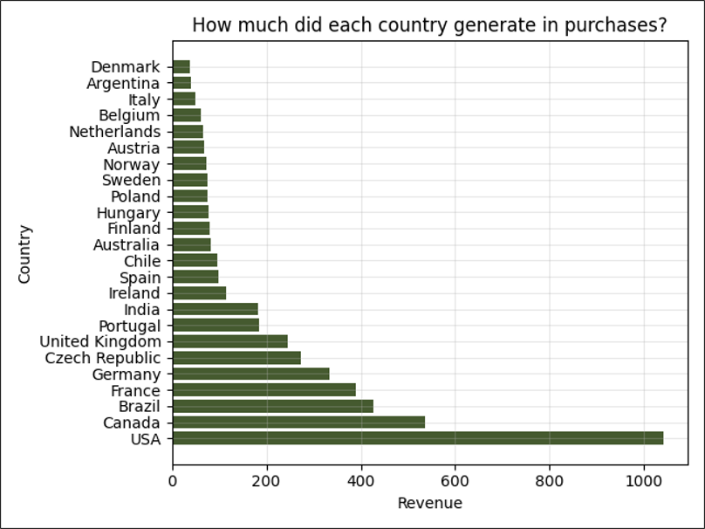
Figure 1. Revenue Generated Per Country
Our visualizations helped us to determine several insights into music purchasing habits across the world. Figure 1 displays the revenue generated by music purchases in each country. The United States had the largest amount of revenue, with nearly twice as much as Canada, the next biggest spender. There is also a large discrepancy in the top genres within the United States.
Songs in the rock genre are purchased much more often than any other genre. There were over 500 purchases of rock tracks, about four times as many as alternative & punk and accounting for over half of all purchases in the United States. Figure 2 shows the relationship between purchases in different genres. It is interesting to note that while metal is the third most purchased genre, heavy metal is the third least purchased genre, with only 28 purchases.
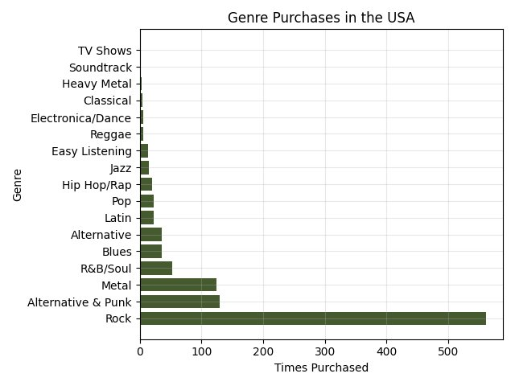
Figure 2. Purchases by Genre in the USA
Figure 3 displays the most purchased rock tracks. “Highway Chile” and “Are You Experienced” were both purchased 14 times from Chinook. “Hey Joe,” “Put The Finger On You,” and “Third Stone From The Sun” were all purchased 13 times. The values for this data are quite close together, suggesting that no song within the rock genre was responsible for a large portion of sales.
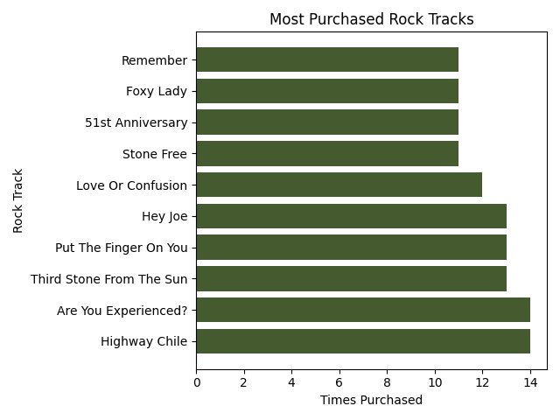
Figure 3. Most Purchased Rock Tracks
Overall, we found that the United States was the largest purchaser of digital music from Chinook by a large margin. Within the United States, the genre of rock made up most sales. The songs “Highway Chile” and “Are You Experienced” are the rock songs with the most purchases.

